**Steps to install Terraform on Amazon Linux**

Run the below commands in Amazon Linux terminal to install terraform-

1. Install yum-config-manager to manage your repositories.  
   sudo yum install -y yum-utils

2. Use yum-config-manager to add the official HashiCorp Linux repository.  
sudo yum-config-manager --add-repo <https://rpm.releases.hashicorp.com/AmazonLinux/hashicorp.repo>

3. Install.  
sudo yum -y install terraform

4. Version  
terraform --version

provider "aws" {

region = "us-west-2"

access_key = "AKIA5LICRRQIXGF9OG"

secret_key = "A72M76JSkpqOeWM95vidaqYQh8NGY8fZJiymE"

}

resource "aws_instance" "terraform" {

ami = "ami-06723030fbcb3cb75"

instance_type = "t2.micro"

tags = {

Name = "naveen"

}

}

[root@ip-172-31-83-153 naveen]# vi aws.tf

provider "aws" {

region = "us-west-2"

access_key = "AKIA5L2XJIFBOG"

secret_key = "A72YopM76JSkqYQV8NGY8fZJiymE"

}

resource "aws_instance" "terraform" {

ami = "ami-0eb5115914ccc4bc2"

instance_type = "t2.micro"

tags = {

Name = "naveen"



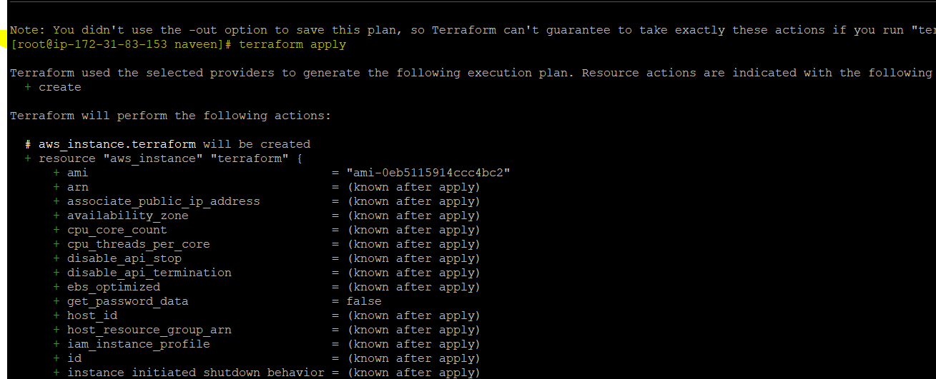

Terraform destroy Command.

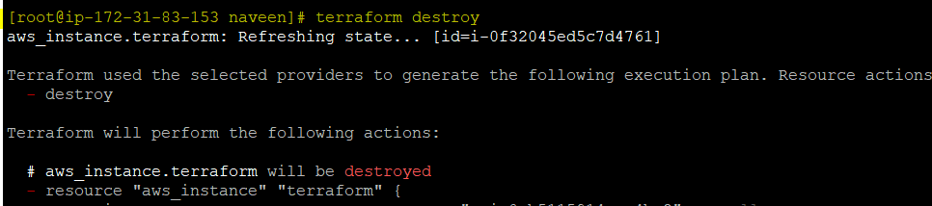

----------------------------------------------Thank you------------------------------------------------------------------